25-02-2010
George K. Aidoo
SM/SMS/09/0019
Physics Practical

Experiment 2

Wheatstone Bridge Experiment (2)

AIM:

The aim of this experiment is to determine the resistance of wires of same material but different diameters.

APPARATUS:

A resistance wire board (1), slide wire measuring bridge (1), connection box (1), standard PEK carbon resistor (1), PEK carbon resistor Q (1), power supply, 5V/1 A, +/-15 V (1), digital multimeter 07134.00 (1), and three 500mm connecting cords (2 each; red, yellow and blue).

DIAGRAM:

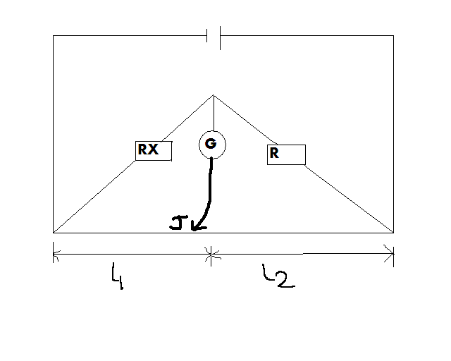

THEORY:

The Wheatstone bridge is an instrument used accurately for measuring resistance and comparing them. At balanced point, the potential at C equals the potential at J, and no current flows through the digital multimeter. The potential difference across R equals the length l₂ and the potential difference across R_{X} equals l_{1.}

Then:

R/ R_{X} = l₂/ l₁ AND R_{X}=R (l₁/ l₂)

For resistor R₁ and R₂ in series, R_{X}= R₁+R₂.
For resistor R₁ and R₂ in parallel, 1/R_{P}= (1/ R₁+1/ R₂).

The resistance of the material of the wire is proportional to its length and inversely proportional to its cross-sectional area, given by the equation:

R α l/A.

PROCEDURE:

The resistances (wires) to be investigated were connected as shown in the diagram above. Resistor Q and the standard resistor R were connected using the connection box. Switching on the power supply, the correctness of the connection was checked by touching the bridge the bridge wire at the extreme ends (X and Y) with the slider jockey, J and the negative and positive readings of the digital multimeter G was observed. The position where there was zero reading on the multimeter represented the balanced point. The lengths l₁ from the end X to the balanced point was recorded, from which l₂ was determined. The procedure was repeated for resistance wires with different diameters.

TABLE OF RESULTS (observations):

L₂ / cm | L₁ / cm | Diameter of wire (mm)
94.3 | 5.70 | 1.00
80.30 | 19.70 | 0.50
89.80 | 10.20 | 0.70
68.00 | 32.00 | 0.35

Capacity of standard resistor R = 10 Ώ

Calculation of Unknown Resistor Q or R_{X}:
Using the formula given in the theory, the value of R_{X} and the area for each wire is determined as follows:

1.00mm wire: R_{X}=R (l₁/ l₂)
R_{X} = 10 Ώ x (5.70cm) / (94.3cm) = 0.60 Ώ
Area:
A = πr² where r is the radius, and r = d (diameter)/2 and π as a constant = 3.14.
Therefore, A = π (1.00mm/2)² = π 0.25mm² = 0.79mm²

0.50mm wire: R_{X}=R (l₁/ l₂)
R_{X} = 10 Ώ x (19.70cm)/(80.30cm) = 2.45Ώ
Area:
A = πr² where r is the radius, and r = d (diameter)/2 and π as a constant = 3.14.
Therefore, A = π (0.50mm/2)² = π 0.06mm² = 0.20mm²

0.70mm wire: R_{X}=R (l₁/ l₂)
R_{X} = 10 Ώ x (10.20cm) / (89.80cm) = 1.14Ώ
Area:
A = πr² where r is the radius, and r = d (diameter)/2 and π as a constant = 3.14.
Therefore, A = π (0.70mm/2)² = π 0.12mm² = 0.39mm²

0.35mm wire: R_{X}=R (l₁/ l₂)
R_{X} = 10 Ώ x (32.00cm) / (68.00cm) = 4.71Ώ
Area:
A = πr² where r is the radius, and r = d (diameter)/2 and π as a constant = 3.14.
Therefore, A = π (0.35mm/2)² = π 0.03mm² = 0.10mm²

Table of Results:

Resistances / Ώ | Length/Area (L/A) | Area of wire / mm² | Length of wire / mm | Diameter of wire (mm)
0.60 | 1265.82 | 0.79 | 1000 | 1.00
2.45 | 5000.00 | 0.20 | 1000 | 0.50
1.14 | 2564.10 | 0.39 | 1000 | 0.70
4.71 | 10,000.00 | 0.10 | 1000 | 0.35

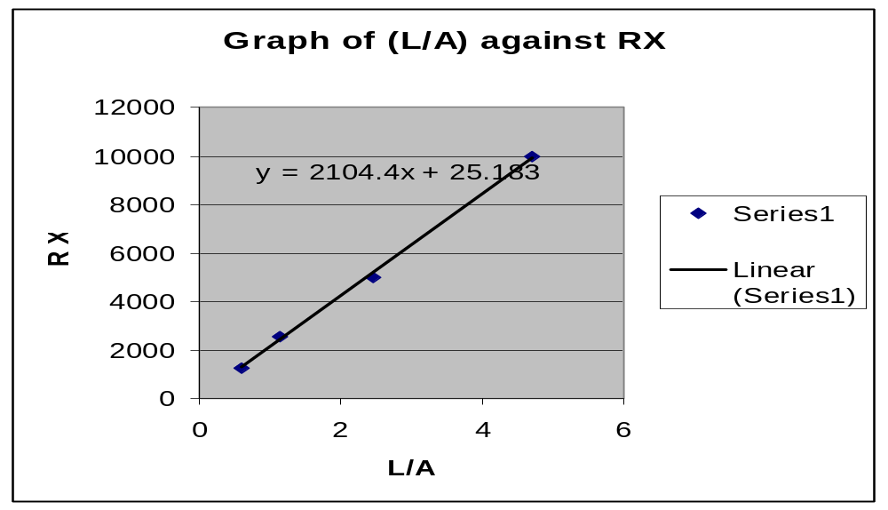

The gradient for the graph is as follows:
Y = 2104.4x + 25.183

DISCUSSION:

According to the results of the values of the resistance determined for the wire of different density, it is evident that the diameter of the string is inversely proportional to the resistance of that wire. For example the wire of diameter 1.00mm had a resistance of 0.60 Ώ, while the wire of diameter 0.35mm had a resistance of 4.71Ώ. The calculated results also confirmed that the resistance of the wire is inversely proportional to its cross-sectional area.

SORCES OF ERROR:

- Error of parallax may have occurred when readings were being taken from the galvanometer.

PRECAUTIONS:

- The correctness of the connection was checked after switching on the power supply to avoid unnecessary errors in the experiment.

- The connections were made tight to avoid inaccurate results.

CONCLUSION:

The aim of the experiment to determine the resistances of wires of same material lengths but different diameters was achieved. The corresponding relationships between the lengths and resistances were also calculated and shown to be as the theory.

REFERENCES:

ATTAKORAH, Paul; Electric and Magnetic Fields and Atomic and Nuclear Physics, Kumasi: Modern Printing Press, 2006, pages 110 – 111.

